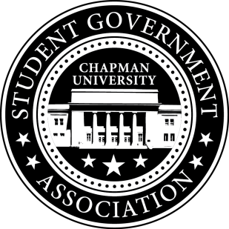
University and Academic Affairs Committee Minutes | October 25, 2017

- Call To Order: Meeting commenced @ 8:00PM
  - Present:
    - Ansley Wong
    - Courtney Wong
    - Alyssa Nowlen
    - Saba Amid - Absent
- New Business:
- Old Business:
a. University and Academic Affairs Outreach
i. Open Forum in Committee Meetings – starting next semester
ii. Feedback Poster – Student Union and Henley Basement
iii. Blackboard Page
- Study Space on Campus
  - Editing Study Space Survey after meeting with Office of Institutional Research
- Sustainability on Campus
  - Encourage students to bring their own cups to Starbucks
    - Still working on getting hard copies of the quotes. Hoping to present the funding to Senate this week.
    - Cocoa and Conversation Event is week before Finals (Monday and Thursday 10am-12pm)
- Senator Updates:
- Senator: Courtney Wong
  - Contacted the Panther about the Green Tip of the week still looking into it.
- Senator: Alyssa Nowlen
  - Meeting with Brittni on Friday to book rooms for study spaces for Schmid College.
  - Scheduled a meeting with Diane Eisenberg on Friday for the TLT advisory board.
- Senator: Saba Amid
  - Reached out to RAs regarding SGA interactions with residence life.
- Senator: Ansley Wong
  - Attallah Student Leadership Council – The first meeting was last Friday. The Chairs went over how the council operates and committees were revealed.

V. Meeting Adjournment: Meeting concluded @ 8:53PM

