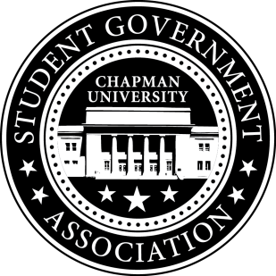
University and Academic Affairs Committee Minutes | October 18, 2017

- Call To Order: Meeting commenced @ 8:00PM
  - Present:
    - Ansley Wong
    - Courtney Wong
    - Alyssa Nowlen
    - Saba Amid
- New Business:
- Old Business:
a. University and Academic Affairs Outreach
i. Open Forum in Committee Meetings – November 1st (Beginning Half)
ii. Feedback Poster – Student Union and Henley Basement
iii. Blackboard Page
- Study Space on Campus
  - Solidified study space survey questions
- Sustainability on Campus
  - Encourage students to bring their own cups to Starbucks
    - Still working on getting hard copies of the quotes.
    - Cocoa and Cram Event is week before Finals (Monday and Thursday 10am-12pm)
- Senator Updates:
- Senator: Courtney Wong
  - Contacted the Panther about the Green Tip of the week.
  - Weigh the Waste is on October 26th 11-1:30pm.
- Senator: Alyssa Nowlen
  - Working on booking rooms as study spaces for Schmid College.
  - Scheduled a meeting with Diane Eisenberg next Friday.
- Senator: Saba Amid
  - Reached out to residence life about senators’ presence in the residential hall.
  - about Looking into cafeteria hours and see if students are satisfied with the hours. Been hearing how students skip breakfast if they have an 8am.
- Senator: Ansley Wong
  - Attallah College Student Leadership Council – The first meeting will be this Friday.

V. Meeting Adjournment: Meeting concluded @ 8:28PM

