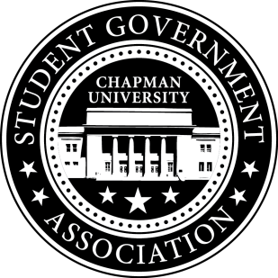
University and Academic Affairs Committee Minutes | October 11, 2017

- Call To Order: Meeting commenced @ 8:00PM
  - Present:
    - Ansley Wong
    - Courtney Wong
    - Alyssa Nowlen
    - Saba Amid
- New Business:
- Old Business:
a. University and Academic Affairs Outreach
i. Open Forum in Committee Meetings – November 1st (Beginning Half)
i. Funding for Food
ii. Feedback Poster – Student Union and Henley Basement
iii. Blackboard Pages
- Study Space on Campus
  - Looked through our study space survey questions
- Sustainability on Campus
  - Encourage students to bring their own cups to Starbucks
    - We are working on the funding powerpoint for full Senate. It should be done by next week.
    - Event is week before Finals (Monday and Thursday 10am-12pm)
- Senator Updates:
- Senator: Courtney Wong
  - Met with Sustainability Committee Meeting
  - Thinking about working with the Panther to create a Green Tip every week.
  - Weigh the Waste is on October 26th 11-1:30pm.
  - Still reaching out to residential life about the Recycle Mania Program
- Senator: Alyssa Nowlen
  - Looking into going to major science lecture and letting students know about her office hours.
  - Scheduled a meeting with Diane Eisenberg at the end of this month.
- Senator: Saba Amid
  - Looking into cafeteria hours and see if students are satisfied with the hours. Been hearing how students skip breakfast if they have an 8am.
- Senator: Ansley Wong
  - Attallah College Leadership Council – The first meeting will be next Friday. Wrote a piece for the Newsletter regarding the Leadership Council.

V. Meeting Adjournment: Meeting concluded @ 9:00PM

