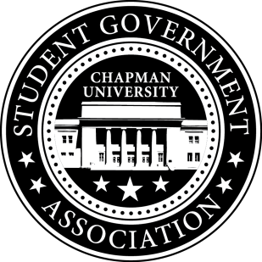
University and Academic Affairs Committee Minutes | October 4, 2017

- Call To Order: Meeting commenced @ 8:00PM
  - Present:
    - Ansley Wong
    - Courtney Wong
    - Alyssa Nowlen
b. Absent
i. Saba Amid
- New Business:
- Old Business:
a. University and Academic Affairs Outreach
i. Open Forum in Committee Meetings – November 1st (Beginning Half)
i. Funding for Food
ii. Feedback Poster – Student Union and Henley Basement
iii. Blackboard Pages
- Study Space on Campus
  - Creating questions for the survey to get concrete data on study spaces on campus.
- Sustainability on Campus
  - Encourage students to bring their own cups to Starbucks
    - We have the quota for the event. We are in the process of creating the funding powerpoint to present to Senate.
    - Event is week before Finals (Monday and Thursday 10am-12pm)
- Senator Updates:
- Senator: Courtney Wong
  - Has a Sustainability Committee Meeting tomorrow.
  - Talked to residential life about the Recycle Mania Program
- Senator: Alyssa Nowlen
  - Contacted Sonya Hall about open space on campus for study spaces for Schmid College waiting to hear a reply.
  - Meeting with Diana Eisenberg of the TLT.
- Senator: Saba Amid
  - Still thinking about what advocacies to pursue looking into Residence Life
- Senator: Ansley Wong
  - Attallah College Leadership Council – The members of the council have been selected. Deciding on when the first meeting will be.

V. Meeting Adjournment: Meeting concluded @ 8:30PM

