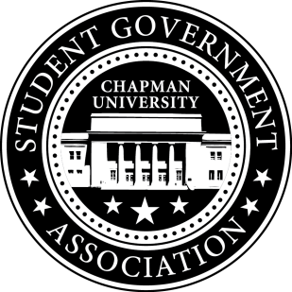
University and Academic Affairs Committee Minutes | September 15, 2017

- Call To Order: Meeting commenced @ 9:00AM
  - Present:
    - Ansley Wong
    - Courtney Wong
    - Alyssa Nowlen
- Old Business:
- Study Space on Campus
  - Looked at the Skyfactor results which was very limited in regards to study space.
  - Next steps: Create a survey looking into various study spaces on campus.
- Sustainability on Campus
  - Encourage students to bring their own cups to Starbucks
    - Event in December before finals week.
    - Looking into getting 200 reusable cups to hand out to students.
- Senator Updates:
- Senator: Courtney Wong
  - Met with the Sustainability Committee
    - Talked about creating a carpool program for students and bike lanes
    - Looking into the Recycle Mania Program
- Senator: Alyssa Nowlen
  - Having a Covalent Bonding Event with other Science Senators next week with the FCA.
- Senator: Ansley Wong
  - Attallah College Leadership Council – meeting with the Associate Dean on Thursday
V. Meeting Adjournment: Meeting concluded @ 9:35AM

