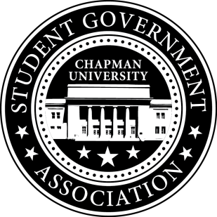
University and Academic Affairs Committee Minutes | September 8, 2017

- Call To Order: Meeting commenced @ 9:00AM
  - Present:
    - Ansley Wong
    - Courtney Wong
    - Alyssa Nowlen
- Old Business:
- Study Space on Campus
  - Looking into getting the Skyfactor results on what students said about study space on campus.
- Sustainability on Campus
  - Encourage students to bring their own cups to Starbucks
    - Tabling near Starbucks in December
  - Professors using Blackboard
  - Lightbulbs in the Dorms – Quote to change all of the light bulbs into LED $133,000
    - Starting with two of the dorms
    - Thinking about funding one of them
- Senator Updates:
- Senator: Courtney Wong
  - Attending the Sustainability Committee next week
- Senator: Alyssa Nowlen
  - Meeting with Eric Cameron, General Manager of Sodexo Dining Services
  - Meeting with Dean Lyon about sustainability and a textbook exchange program.
- Senator: Ansley Wong
  - Attallah College Leadership Council – working on the logistical elements
    - Applications are coming out in the Attallah College Newsletter on Monday
  - Blackboard – SGA page
    - Working on contacting those who are in charge of the Blackboard page
V. Meeting Adjournment: Meeting concluded @ 9:35AM

