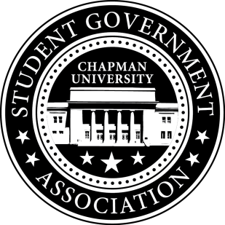
Community Outreach Committee Minutes | October 26, 2017

- Call To Order: Meeting commenced @ 7:05 PM
  - Present:
    - Maytal Sarafian
    - Alysa Buckler
    - Molly Weber
b. Absent
- Old Business:
a. Treats in the Streets – 10/26
b. OHS Farm Improvement Day – 10/21
- Senator Updates:
- Senator: Maytal Sarafian
  - Health Center
    - Spoke with Mitchell and reviewed past survey
  - Senator Brunch
    - Helped plan agenda and logistics
- Senator: Alysa Buckler
  - Met with Mitchell for One-on-One
    - Wishes to meet with Public Safety to talk about Bike Theft Safety and possibly preparing pamphlets to hand out in front of dorms
    - Security cameras in the Lastinger
- Senator: Molly Weber
  - Senator Brunch
    - Asked Senators for availability on November 9th
    - Will meet with Brittni and Lisa to talk about booking rooms
    - Helped plan agenda and logistics
  - Plans to create SGA Calendar
- Senator: Lisa Kang
  - Edited and submitted Operating Documents to Speaker
  - Korean Language Courses Initiative
    - Met with ASL Professor Dr. Tamer
    - Met with Korean Student Association President
    - Researched colleges and universities that offer Korean languages
    - Reached out to CSUF students and asked for their feedback
    - Plan to create a survey
  - Chapman Dog Day – 2/3/2018
    - Plan to submit a UPB collaboration form by November 10th
    - Created google doc for Members to answer questions
V. Meeting Adjournment: Meeting concluded @ 8:07 PM

