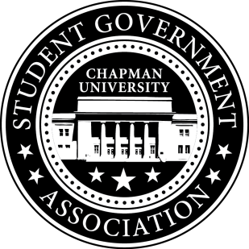
Community Outreach Committee Minutes | October 12, 2017

- Call To Order: Meeting commenced @ 7:00PM
  - Present:
    - Maytal
    - Molly Weber
b. Absent
i. Alysa Buckler
- Old Business:
- Senator Updates:
- Senator: Molly
  - Senator Brunch
    - Plans to post a poll on Facebook to gather everyone’s availability
    - Reviewed food options on Sodexo Catering page
- Senator: Maytal
    - Mentions getting cameras in Lastinger
- Senator: Lisa
  - Reserved a table for SGA at the Treats in the Street Festival – 10/26
  - Plans to coordinate OHS Farm Improvement Day with Jack and SGA
  - Discussed Town Hall Meeting with Committee
V. Meeting Adjournment: Meeting concluded @ 8:10 PM

