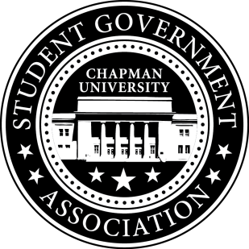
Community Outreach Committee Minutes | October 5, 2017

- Call To Order: Meeting commenced @ 7:00PM
  - Present:
    - Maytal Sarafian
    - Molly Weber
    - Alysa Buckler
b. Absent
i. n/a
- Old Business:
- Senator Updates:
- Senator: Molly
  - Senator Brunch
    - Plans to have it on Thursday November 9th 11-12:30PM at the AF Student Union Stage
- Senator: Maytal
  - Called Emily Director of Recreation Services
  - Mentioned problems in the café (limited gluten free options and fruit options)
  - Plans to attend Fall at the Market event at the Farmer’s Market – 10/21
- Senator: Lisa
  - Korean Language Courses
    - Continuing student petition and sent student petition file to Speaker of Senate Alex and COPA Senator Ian
    - E-mailed Nina for ethnic demographics statistical information
    - Plans to create infographic on statistical information
  - Chapman Dog Day
    - Sent outline of purpose and logistics to UPB Chair
    - Plans to follow-up with UPB Chair Snay
  - Treats in the Streets – 10/26
    - Got a booth via Jack
    - Plans to look for resources and giveaways with Molly to have at the event
- Meeting Adjournment: Meeting concluded @ 7:53 PM

