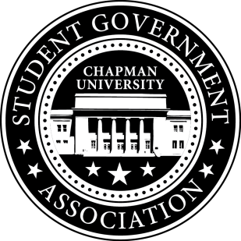
Community Outreach Committee Minutes | September 27, 2017

- Call To Order: Meeting commenced @ 8:10AM
  - Present:
    - Maytal
    - Molly Weber
b. Absent
i. n/a
- Old Business:
- Senator Updates:
- Senator: Molly
  - Plans to organize senior brunch that will be happening possibly in November
- Senator: Maytal
  - Plans to call Director of Recreation Services on upcoming events in Orange
- Senator: Lisa
  - Finalized volunteers for Socktober Homecoming with Michael
  - Started Korean language program petition and met with professor Nam
  - Spoke with Chair of UPB on collaborating for Chapman Dog Day
  - Began outlining purpose, logistics and timeline with Committee
V. Meeting Adjournment: Meeting concluded @ 8:56 AM

