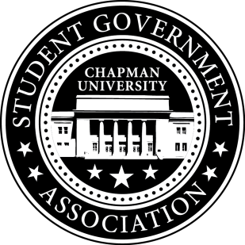
Academic Committee Minutes | September 5, 2017

- Call To Order: Meeting commenced @ 7:05PM
  - Present:
    - Alysa Buckler
b. Absent
i. n/a
- Old Business:
  - n/a
- Senator Updates:
- Senator: Alysa Buckler
  - Discuss having freebies and raffle tickets on Chapman Dog Day
  - Plans to follow-up with Molly on Chapman’s Merchant Day flyers
- Senator: Lisa Kang
  - Met with Elliot to discuss last year’s Chapman Dog Day
  - Spoke to Molly on creating Instagram and Facebook posts on Chapman Merchant’s Day
  - Contacted Alisa from Community Relations Department on setting up another meeting
  - Plans to contact Panhellenic and IFC on getting volunteers for Socktober Homecoming – 10/7
V. Meeting Adjournment: Meeting concluded @ 7:40 PM

