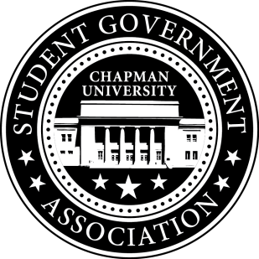
Academic Committee Minutes | March 4, 2016

- Call To Order: Meeting commenced @ 12:00 PM
  - Present: All
  - Late/Absent: None
- Old Business:
  - Study Space Survey will be presented to the Academic Committee for feedback
- Senator Updates:
  - Senator: Priya Patel
    - Priya will present the survey to Director of PR and then open it to students.
  - Senator: Amanda Moore
    - Amanda will meet with the head of the Academic Integrity Committee for guidance in her Academic Integrity Project. Using this guidance she will create a plan to make faculty aware of the fact that students do not understand the policy in its entirety.
    - She will continue with her plan to put on an Academic Integrity Week in which she will table in the Piazza and raise student awareness of the policy.
  - Senator: Skylar Goss
    - Skylar met with the Assistant Dean of the Business School and received support for the charging station project.
  - Senator: Jayetha Panakkadan
    - Jayetha met with Dean Lyon of Shmid College regarding MKAT scholarships. Dean Lyon is in support of the idea of providing scholarships for students taking the MKAT. He suggests that SGA and Shmid fund the scholarship through co-sponsorship.
  - Senator: Setareh Motamedi
    - Setareh will meet with Dodge Professor Sally Rubin and Dodge student Leon Lukic to plan production on the diversity in curriculum video.
- Meeting Adjournment: Meeting concluded @ 12:30 PM

