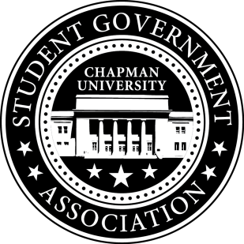
Academic Committee Minutes| March 31, 2016

- Call To Order: Meeting commenced @ 7:00 PM
  - Present:
    - Amanda Moore
    - Priya Patel
    - Skylar Goss
  - Absent:
    - Jayetha
- Old Business:
- Group Advocacy:
  - We will work as a group to survey student’s feelings towards our library being open to non-students.
- Senator Updates:
  - Senator: Amanda Moore
    - Amanda reached out to Dr. Lambert of the Disabilities Minor to see how she could help promote the minor.
    - She will speak with Kayla about tabling dates for Academic Integrity week.
  - Senator: Priya Patel
    - Priya has received 162 responses on her Study Space Survey. Of the 162, 75% are unsatisfied with study space on campus, 72% prefer to study individually, and the 3 areas in the library which students wish to see greater availability are individual cubbies, communal tables, and collaborative study rooms.
  - Senator: Skylar Goss
    - Skylar is still trying to contact Ken Murai, head of Facilities Management to get approval for the charging station installation. He should be receiving a response by the end of the week.
  - Senator: Setareh Motamedi
    - Setareh will be filming student interviews with Leon Lukic. They are gathering student testimonials of experiences in the classroom regarding diversity.
- Meeting Adjournment: Meeting concluded @ 7:45PM

