Chapman University

Professor Erin Crockett Professor Brennan McDavid
Business/Economics Philosophy
bcrockett@chapman.edu mcdavid@chapman.edu

Course Syllabus

ECON-ENG-PHIL 357 Topics in Humanomics

Shame: The Civilizing Emotion

Fall 2021

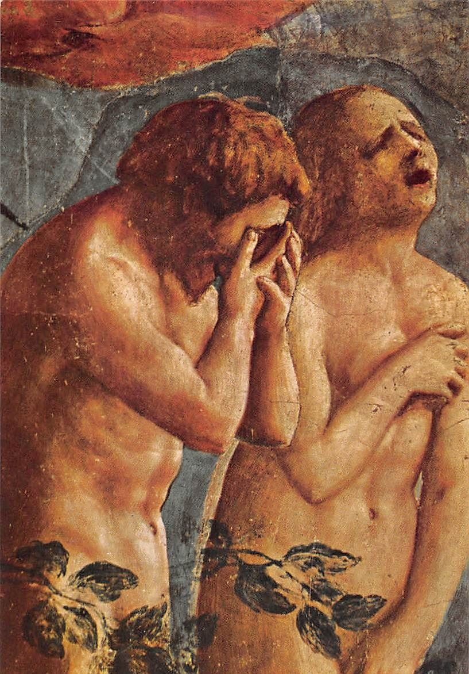

“It is a painful thing
To look at your own trouble and know
That you yourself and no one else has made it”
― Sophocles

Course Description
Eyes cast down. Flushed cheeks. The face of shame is universal and familiar. We know it when we see it, and—what’s more—we know shame when we feel it. What is shame, though, and why do we find it in every culture? What, if any, advantage does it serve for the individual, for the society, for the species?
Humanomics courses adopt a distinctively interdisciplinary approach in responding to such essential questions. We will engage with philosophy, economics, and art (particularly novels, plays such as Ajax quoted above, and historically significant paintings). Each of these disciplines takes shame into consideration on its own terms, utilizing its unique tools of analysis and expression. We will explore what each discipline is able to accomplish by way of advancing our understanding of shame and enhancing, bettering our relationship to it. Though we begin with the premise that each of these disciplines accomplishes something distinct, we are also motivated to think about what they create together, the sum product of interdisciplinary inquiry. Below is a brief sketch of how we aim to fill out our study.

Value Inquiry: Shame has been recognized since the time of Plato in ancient Athens as a distinctively moral emotion. We will read the so-called “Great Speech” in Plato’s Protagoras where an aetiological account of shame is provided. Sophocles’ Ajax additionally presents us with a more popular depiction of shame in ancient Athens, complementing the esoteric depiction in Plato’s philosophy. Adam Smith furthers the project, building a theory of moral emotions as social tools. His account, like Plato’s, is largely optimistic about the role of shame in our moral and social lives. The Ajax account and Krista Thomason’s Naked stand out as pessimistic, forcing us to face the destructive power of shame for individuals and even society at large.

Social Inquiry: From the spring board of the philosophical claim (from Plato and Adam Smith) that shame is a social tool that aids cooperation and advances the flourishing of our species, we examine work that aims to test that hypothesis and observe it “in the wild,” i.e. in the real world. We will explore how compensation structures contribute to what Tirole and Benabou describe as a “bonus culture,” which could incentivize shameless behaviors and lead to inefficient economic outcomes. Along the way we will learn about the conditions that gave rise to the 2008 Great Recession (e.g., asset bubbles, conflicts of interest at the credit rating agencies, mortgage-backed securities fraud). We will use classroom experiments and review the experimental literature relating to asset bubbles. These explorations in finance are meant to encourage an appreciation for how precarious financial markets can be, and why shameless behavior in that arena can wreak havoc for society.

Artistic Inquiry: Our engagement with art will be multi-faceted. Students will both encounter artistic depictions of shame and produce artistic depictions of shame. Art utilizes forms of expression that represent and criticize ideas sometimes directly, but sometimes also obliquely. We will consider a range of such forms, beginning with the strategies inherent to high tragedy: the reliance on the familiar for driving a tragic impact, the crafting of the tragic hero, and the balancing of the Nietzschean Dionysian and Apollonian in human nature. In reading Salman Rushdie’s Shame, we examine the tragic metaphor as expressed through magical realism, paying particular attention to Rushdie’s deployment of satire and post-modern techniques. With James Baldwin’s Giovanni’s Room, we encounter confession stylized as art, an intimate expressiveness that invites us to occupy an alternate perspective. Throughout the term, we will be confronted with additional visual modes of art, both static forms and in motion picture, that study shame.

3 credits. (AI, SI, VI)
Required Books and Essays
- Baldwin, James. Giovanni’s Room: A Novel. 1956
- Lewis, Michael. Liar’s Poker. 1989.
- Plato. Protagoras.
- Rushdie, Salman. Shame. 1983
- Smith, Adam. The Theory of Moral Sentiments, Part III, chapter II.
- Sophocles. Ajax.
- Thomason, Krista. Naked: The Dark Side of Shame and Moral Life.

Required Academic Papers and Conferences

- Benabou and Tirole. “Bonus Culture: Competitive Pay, Screening, and Multitasking.” Journal of Political Economy, 2016, vol. 124, no. 2 (pp. 305-314; 343-348)
- November 26, 2013 - Principles of Responsible Investment (PRI) Academic Network Conference. Keynote Address by Jean Tirole: Bonus Culture: Competitive Pay, Screening, and Multitasking
(https://www.youtube.com/watch?v=k28Oh5MY1Qs)
- Smith, Suchanek, and Williams. “Bubbles, Crashes, and Endogenous Expectations in Experimental Spot Asset Markets.” Econometrica, 1988, vol. 56, no. 5 (pp. 1119-1151)
- Crockett, Duffy, and Izhakian. “An Experimental Test of the Lucas Asset Pricing Model.” Review of Economic Studies, 2019, vol. 86, no. 2, pp. 627-667.

Required TED Talks and Podcasts
- March 20, 2015 - TED Talk by Monica Lewinsky: The Price of Shame
(https://www.youtube.com/watch?v=H_8y0WLm78U)

Required Movies
- Imitation of Life (1934)
- Wall Street (1987)
- The Wolf of Wallstreet (2013)

General Education Learning Outcomes
- AI/Artistic Inquiry: Student composes critical or creative works that embody or analyze conceptually an artistic form.
- SI/Social Inquiry: Student identifies, frames, and analyzes social and/or historical structures and institutions in the world today.
- VI/Values/Ethics Inquiry: Student articulates how values and ethics inform human understanding, structures, and behavior.

Course Learning Outcomes
Student will . . .
- Ask cogent, thought-provoking questions based upon critical engagement with works across a range of genres; e.g., academic papers, literature, film.
- Articulate an account of shame, referencing some theories of the origins of shame as well as causes of its erosion and reflecting on the value of shame in the flourishing of both individuals and societies.
- Examine depictions of shame in art, particularly fiction, considering how literary form expresses and conveys the place of shame in human relationships and the impact of shame on personal development and flourishing.
- Explain the value of shame according to arguments in philosophy and social science. Reflect on the extent to which communities have realized that value and the place of that value in relation to the flourishing of both individuals and societies.
- Demonstrate thoughtful rhetorical choices in creative and expository prose.

Program Learning Outcomes
Economics
- Knowledge of Economics: Each student will demonstrate knowledge of modern microeconomic theory and apply it to analyze economic policies and problems.
- Communication: Each student will be able to communicate clearly, concisely and professionally in both written and oral forms.
English
- Skill in critical reading, or the practice of identifying and interpreting the formal, rhetorical, and stylistic features of a text.
- Write demonstrating proficient use of genre elements, techniques, and conventions to produce a defined work: story, poem, or creative non-fiction.
Philosophy
- Ability to reason logically, effectively, and respectfully about ethical matters
- Writing ability to state and support a thesis, apply knowledge of critical reasoning, accurately interpret philosophical sources, and clearly communicate a balanced account in writing.

Instructional Strategies
This course is student-centered and employs a seminar-style round table discussion in every class session. Students are made responsible for moving discussion through preparation in (i) reading the session’s assigned material, (ii) submitting questions pertaining to that material at the beginning of the session and (iii) respectfully offering their questions, insights, observations, and ideas to the class for consideration. We will also develop Individual skill in crafting questions and articulating original ideas through expository and creative papers, writing workshop, and an oral final examination.

Evaluation

- Participation in Class Discussions [10%]
Class discussion provides an opportunity for students to explore questions about trust and the human condition, challenging the common perception of economics as distinct from the humanities while exploring the concept through artistic, economic, and philosophical frames. Through this shared inquiry, students gain experience reading for meaning and communicating complex ideas; thinking reflectively about an interpretive problem; and supporting and testing thoughts through dialogue with peers. Class discussion fosters the flexibility of mind to consider problems from multiple perspectives and the ability to analyze ideas critically. Students must enter the discussion with specific questions generated by the texts as well as a desire to probe and reevaluate ideas. It is essential that students bring texts and questions to each class session.

- Written Questions [10%]
Shared inquiry is a process for exploring the central ideas of the course. This means students must read for meaning, identifying possible interpretative problems they would like to address in discussion. For each class period with an assignment, students will word process two questions to be handed in before class starts. Asking a good question is harder than providing a good answer. The student’s task is to delve into a claim or artistic expression that doesn’t appear correct or consistent with their understanding of trust or the human condition. They can explore, through the question, why the claim or artistic expression is surprising, unexpected, or unsettling. In addition, for the assigned class periods, students will bring an artifact, an item specified in the course schedule that will provide evidence of text interpretation.

- Writers Workshop [20%]
Based on the idea that we develop as writers when we write often, the writers workshop provides an opportunity to focus attention on ideas from the readings and discussions immediately preceding the workshop. An important component of the workshop is to provide a space to explore each week’s material in its social, scientific, philosophical, and/or artistic context. Students will encounter a variety of writing assignments for workshop, including both critical and creative works. We will use writers workshop to provide touchstones in the process of moving from exploratory thinking and writing to submitted products.

- Projects: Critical, Creative [40%]
Part of the meaning-making process, of discovering meaning in texts in dialogue with one another and with the experiential component of the course, is developing connections in projects of either/both an expository/analytical and a creative nature. The students will produce two projects over the semester. One will be an expository/analytical paper of academic tone, and the other will be the production of an artistic work.
- Critical project: Students will produce one essay of 1,000 words (maximum) answering a question prompt provided to the class by the instructors. The question will pertain to the topic of shame as we have been analyzing it conceptually and via social scientific methods in our discussions and readings. Critical projects will be evaluated for their rigor, concision, and structure in building their analysis.
- Creative project: Students will produce one work of art in answer to a question prompt provided to the class by the instructors. The aim of this project is to utilize the question as a vehicle for exploring one of the art forms that we have been engaging with in our discussions, readings, and encounters with visual art. Students are invited to choose the form they wish to explore among painting, sculpture, film, poetry, monologue, screenplay, theatrical play or tragedy, dance, photography, music, or short story. This list is not intended to exhaust possibilities, and students are welcome to consult with the instructors in their ideas of forms to explore. Demonstration of an understanding of the skills involved in the creative process will be evaluated, as will the final product. In particular, creative projects will be evaluated for their depth and breadth of engagement, including sophistication of deployment of techniques special to the selected form of expression.

- Oral Final Examination [10%]
Students will consider the course objectives for Shame: The Civilizing Emotion and respond to questions posed by the professors in an individual oral examination.

Because of the interactive nature of the class, attendance is an essential component. Excessive tardies constitute absences; six absences may result in failure (Undergraduate Catalog 2019-2020, “Academic Policies and Procedures”). Please keep this in mind. Missed in-class work cannot be made up.

Chapman University Policies

Academic Integrity Policy
Chapman University is a community of scholars that emphasizes the mutual responsibility of all members to seek knowledge honestly and in good faith. Students are responsible for doing their own work and academic dishonesty of any kind will be subject to sanction by the instructor/administrator and referral to the University Academic Integrity Committee, which may impose additional sanctions including expulsion. Please see the full description of Chapman University's policy on Academic Integrity at:
www.chapman.edu/academics/academicintegrity/index.aspx.

Students with Disabilities Policy
In compliance with ADA guidelines, students who have any condition, either permanent or temporary, that might affect their ability to perform in this class are encouraged to contact the Disability Services Office. If you will need to utilize your approved accommodations in this class, please follow the proper notification procedure for informing your professor(s). This notification process must occur more than a week before any accommodation can be utilized. Please contact Disability Services at (714) 516–4520 or visit https://www.chapman.edu/students/health-and-safety/disability-services/ if you have questions regarding this procedure or for information or to make an appointment to discuss and/or request potential accommodations based on documentation of your disability. Once formal approval of your need for an accommodation has been granted, you are encouraged to talk with your professor(s) about your accommodation options. The granting of any accommodation will not be retroactive and cannot jeopardize the academic standards or integrity of the course.

Equity and Diversity Policy
Chapman University is committed to ensuring equality and valuing diversity. Students and professors are reminded to show respect at all times as outlined in Chapman’s Harassment and Discrimination Policy. Please see the full description of this policy at http://www.chapman.edu/faculty-staff/human-resources/eoo.aspx
Any violations of this policy should be discussed with the professor, the dean of students and/or otherwise reported in accordance with this policy.

Tentative Course Schedule

Week | Dates | Reading/Writing | Assignments
1 | Aug 30 | Introductions, Course Overview, What is Shame?, in class reading/performance of tragic scenes
 | Sept 1 | Plato’s Protagoras, the “Great Speech” | Questions  WW
2 | Sept 6 | Labor Day
 | Sept 8 | Sophocles, Ajax | Questions
3 | Sept 13 | Adam Smith TMS, Part III, Chap. II: Of the love of Praise, and of that of Praise-worthiness; and of the dread of Blame, and of that of Blame-worthiness | Questions
 | Sept 15 | James Baldwin, Giovanni’s Room | Questions  WW in class
4 | Sept 20 | James Baldwin, Giovanni’s Room | Questions
 | Sept 22 | Salman Rushdie, Shame, Part I | Questions
5 | Sept 27 | Salman Rushdie, Shame, Part II | Questions  WW
 | Sept 29 | Salman Rushdie, Shame, Part III | Questions
6 | Oct 4 | Salman Rushdie, Shame, Part IV | Questions  Project 1 Due Expository
 | Oct 6 | Salman Rushdie, Shame, Part V | Questions
7 | Oct 11 | Michael Lewis, Liar’s Poker, chapters 1, 2, and 3 (1–98) | Questions
 | Oct 13 | Michael Lewis, Liar’s Poker, chapters 4 and 5 (99–166). | Questions  WW
8 | Oct 18 | Michael Lewis, Liar’s Poker, chapters 6 and 7 (129–188) | Questions
 | Oct 20 | Michael Lewis, Liar’s Poker, chapters 8 and 9 (189–254) | Questions
9 | Oct 25 | Michael Lewis, Liar’s Poker, chapters 10–11 and epilogue (255–309) | Questions  WW
 | Oct 27 | Wallstreet (film); Wolf of Wallstreet (film) | Questions
10 | Nov 1 | In class experiment | Questions
 | Nov 3 | Smith, Suchanek, and Williams. “Bubbles, Crashes, and Endogenous Expectations in Experimental Spot Asset Markets.”; | Questions  Paper 2 Due Creative
11 | Nov 8 | Benabou and Tirole. “Bonus Culture: Competitive Pay, Screening, and Multitasking”; | Questions
 | Nov 10 | Benabou and Tirole. “Bonus Culture: Competitive Pay, Screening, and Multitasking”; | Questions  WW
12 | Nov 15 | Crockett, Duffy, and Izhakian. “An Experimental Test of the Lucas Asset Pricing Model.” | Questions
 | Nov 17 | Imitation of Life (film); Monica Lewinsky Ted Talk | Questions
13 | Nov 29 | Krista Thomason, Naked, Introduction and chapter 1 (1–50) | Questions
 | Dec 1 | Krista Thomason, Naked, chapters 2 and 3 (51–125) | Questions  WW
14 | Dec 6 | Krista Thomason, Naked, chapters 3 and 4 (126–174) | Questions  WW
 | Dec 7 | Krista Thomason, Naked, chapter 5 and conclusion (175 - 220) | Questions
 | TBD | Final Examination

Syllabus Prepared by B. McDavid and B.E. Crockett, Fall 2021

