ECON/ENG/PHIL 357 - Topics in Humanomics – What Is Progress?

INSTRUCTORS: Professor Dillon Tauzin (tauzin@chapman.edu) and Professor Brennan McDavid (mcdavid@chapman.edu)

COURSE MEETINGS: M-Th 9:00-11:50 – Location WH 220

OFFICE HOURS: We will have joint office hours by request. Try to give us some notice, but we will usually be available after class.

PREREQUISITES: None

RESTRICTIONS: Faculty Consent Required
COURSE COMMUNICATIONS: The vast majority of classroom communications will take place through email (typically via the dedicated course Canvas site). YOU ARE RESPONSIBLE FOR MAKING SURE THAT YOU RECEIVE THESE COMMUNICATIONS. We are a team, so if you email one of us, email both of us.
Description: A popular view today is that progress is inexorable: having set the machine of technological society in motion, we should expect it to continue forever. But is that a reasonable assumption? Looking to history it seems that long periods of progress have often eventually ended in gradual, or even catastrophic, decline. Is this time different? Why or why not? And what is progress, anyway? Perhaps we think we know it when we see it. Economists typically emphasize a material notion progress. When populations grow, wealth accumulates, productivity increases, and health improves, this is taken to be evidence of progress. But we can also speak of moral progress, scientific progress, social progress, political progress, artistic progress, and so on. Do these notions of progress necessarily go hand in hand? What kinds of value judgments are lurking beneath the surface of empirical claims about progress? If progress means advancing towards some goal, what is that goal? Who gets to define it?

Humanomics classes (like this one) adopt a distinctively interdisciplinary approach. Throughout the term, we will address these questions through the lenses of economics, philosophy, and art (particularly ancient poetry and modern cinema). We will not just ask what these disciplines have to say about our topic independently of one another; we will also ask how these disciplines interact, enrich each other, and have unique ways of capturing different dimensions of reality. The overarching idea is that there are many ways of expressing important ideas and that focusing on any one form of expression (social scientific, philosophical, artistic) in isolation is bound to leave important aspects of those ideas unstated, or incompletely expressed. Moreover, by working with media situated in a variety of historical contexts, we will necessarily ask why a set of ideas have been expressed in different ways in different times and places, and how this form of expression affects what’s being said. Below is a brief sketch of how we aim to fill out our study.
Value Inquiry: Socrates was the first philosopher to submit ethical considerations to philosophical scrutiny, a sign of intellectual and moral progress in how deeply human beings are able to engage with their own beliefs about how to live well. But he was also executed by his fellow Athenians. We begin our study of moral progress with Plato’s Apology, in which the power of rationality is heralded as a driver of all things good. Knight’s Ethics of Competiton will direct our attention to the question of how our conception of the good can change. Stubborn Attachments by Tyler Cowen will argue for certain values that weigh the future as heavily as the present.

Social Inquiry: 5th century Athens and the long-enduring empire of Rome are ready examples of civilizations that progressed magnificently and also—perhaps inexplicably—declined. We will examine each of these ancient civilizations through recent archaeological evidence, considering the mechanisms that allowed them to grow and flourish as well as those that resulting in decline. Ober’s work on Greece will lead us through democratic Athens, and we will encounter the epic end of empire in Rome through Bryan Ward-Perkins' The Fall of Rome and complementary podcast interviews with active scholars. Turning to our modern world, Brad DeLong describes what he calls the ”long twentieth century”––not as a march of material progress––but as a slouch toward utopia.

Artistic Inquiry: Our engagement with art allows us to consider the possibility of aesthetic progress. Any student of art history will be familiar with progression in certain aspects of visual art, for example the understanding of perspective. We will engage with purported examples of progress in ancient verse (comparing the dramatic styles of Aeschylus and Euripides with one another and these together with the epic style of Vergil in his Aeneid). The study of verse will reveal developments in narrative exposition, representation of character motives, formality and tone, dramatic irony, even while some devices remained constant (e.g. peripety, anagnorisis). We will also examine Chaplin’s depiction of burgeoning modernity in Modern Times, as well as the bleak dystopia in Gilliam’s Brazil. With these films, we will consider differences in comedic approach, aesthetic value, and portrayals of “progress.” The written and visual media provide distinct domains for testing the hypothesis that aesthetic progress is possible. Lastly, in Thornton Wilder’s Our Town, which rejects many of the standard rules of narrative, we will consider the relationship between progress and simplicity.

Required Texts:
The Greek Plays: Sixteen Plays by Aeschylus, Sophocles, and Euripides. 2016. Random House. ISBN: 978-0812993004
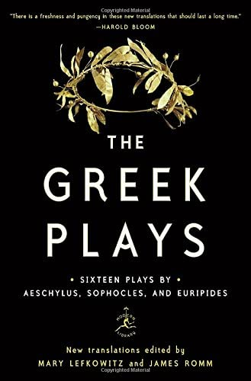

Cowen, Tyler. Stubborn Attachments. 2018. Stripe Press. ISBN: 978-1732265134

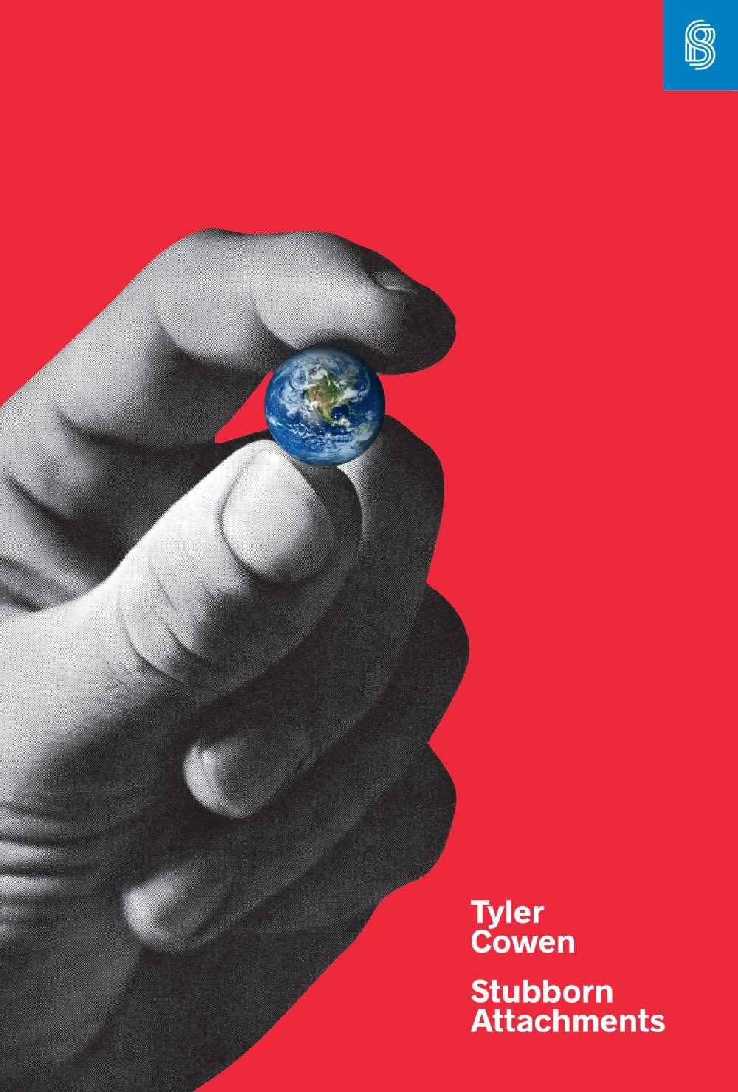

DeLong, J. Bradford. Slouching Toward Utopia: An Economic History of the Twentieth Century. 2022. Basic Books.

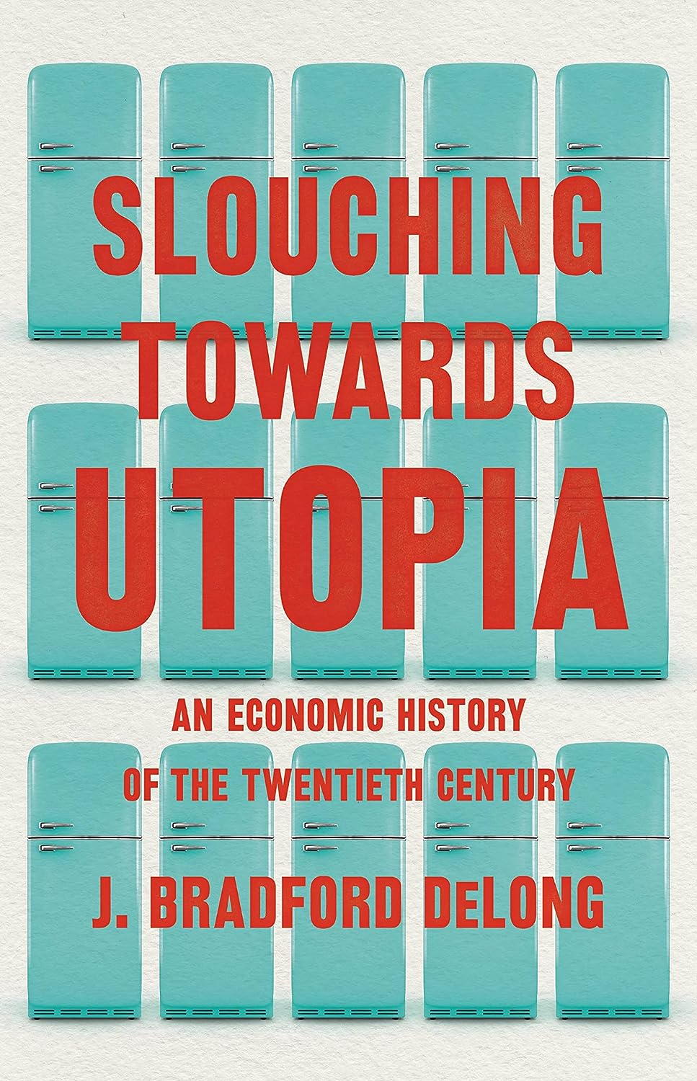

Ober, Josiah. The Rise and Fall of Classical Greece. 2015. Princeton University Press.

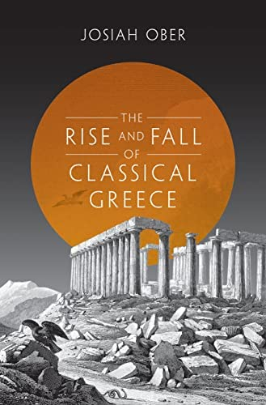

Plato. Five Dialogues: Euthyphro, Apology, Crito, Meno, Phaedo. 2002. Hackett Publishing. ISBN: 978-0872206335
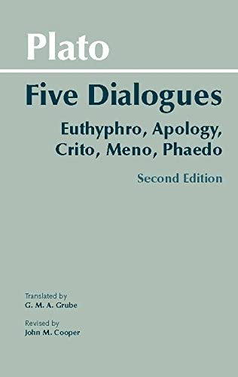

Temin, Peter. The Roman Market Economy. 2017. Princeton University Press. ISBN:‎ 978-0691177946

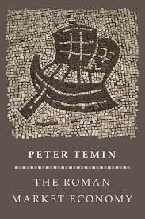

Virgil. The Aeneid. Shadi Bartsch (translator). 2021. Random House. ISBN: 978-1984854100
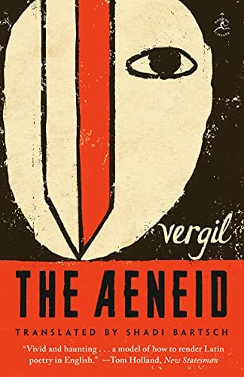

Wilder, Thornton. Our Town: A Play in Three Acts. 2020. Harper Perennial Modern Classics. ISBN: 978-0063003996

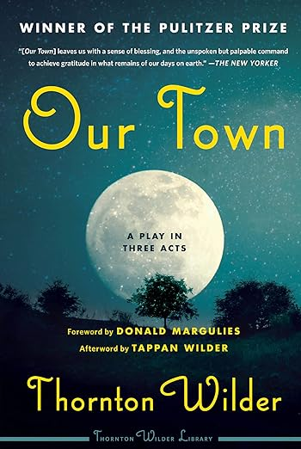

Articles:
Bauer, Peter. 2000 “From Subsistence to Exchange.” From Subsistence to Exchange and Other Essays. 3-14.
Keynes, John Maynard. 1963 “Economic Possibiilties for our Grandchildren.” Essays in Persuasion. 358-373.
Knight, Frank H. 1923. “The Ethics of Competition.” Quarterly Journal of Economics. Vol 37. No. 4. 579-624.

Podcasts:
Wyman, Patrick. The Fall of Rome. “Interview: Historian Kyle Harper on Disease, Climate and the Fall of the Roman Empire.”

Films:
Modern Times 1936
Brazil 1985

Course Schedule (subject to change, assignments updated as we go):
Date | Readings | Assignment
3-Jan | Ober Preface, Ch. 1-3 (80pp); Aeschylus’s Agamemnon (50pp) | Experiment 1
4-Jan | Ober Ch. 4-5 (52pp); Euripides’ Bacchae (48pp) | Writer’s Workshop 1
5-Jan | Ober Ch. Choose 1 of Chs. 6-10, Ch. 11 (50+pp); Apology (24pp) | Writer's Workshop 2
9-Jan | Temin Ch. 1-3 (69pp); Virgil’s Aeneid, books 1-2 (48pp) | Debate Club 1
10-Jan | Temin Ch. 4-6 (68pp); Virgil’s Aeneid, books 4 & 6 (50pp) | Writer's Workshop 3
11-Jan | Temin Ch. 9-11 (69pp); Harper Interview | Draft of Paper 1 Due
12-Jan | Clark Ch. 1-3 (70pp); Virgil’s Aeneid, books 8 & 12 (55pp) | Project 1 Due
17-Jan | DeLong Ch. 1-3 (114pp); Modern Times | Experiment 2
18-Jan | DeLong Ch. 4-6 (90pp.); Bauer (11pgs) | Writer's Workshop 4
19-Jan | DeLong Ch 7-9 + Conclusion (94pp.) | Data Graphic Brainstorm
23-Jan | Knight (47pp). Brazil | Data Graphic Presentation
24-Jan | Our Town (104pp.) Lazarus Lake podcast | Debate Club 2
25-Jan | Cowen Ch. 1-3 (48pp.); [AI Ethics] | Writer's Workshop 5
26-Jan | Cowen Ch. 4-6 (64pp.); Keynes (7pp) | Project 2 Due

Course Learning Outcomes:
- Challenge and deconstruct the perceived tensions between economics and the humanities.
- Ask cogent, thought-provoking questions based upon critical reading of texts across a range of artistic, philosophical, and historical genres—film, fiction and non-fiction.
- Explain theories of progess, including their assumptions and their implications.
- Examine how our notions of progress shape our behavior, our understanding of the world and our relation to social structures.
- Explain the relation of notions of progress to systems and structures in historical, political and social context: ancient Greece and Rome, early Industrial England, 19th Century America, contemporary society.
- Explain methods used to measure progress (e.g. surveys, experiments, ethnographies).
- Explore the relationship between progress, economic institutions and economic decision-making.
- Examine formal and aesthetic characteristics of film (particularly choices in lighting, editing, cinematography, music and soundscape, performance) and ancient verse (characterization, narrative structure, metrical choices, ekphrasis, and symbolism).
- Scrutinize formal aspects of artistic works for their purported evidence of aesthetic progress.
- Explain how artistic works may reflect progress (and regress) of people, institutions, and societies in their historical context.
- Articulate how texts across the disciplines are co-constitutive of knowledge, ethics, and aesthetics.
- Demonstrate thoughtful rhetorical choices in creative and expository prose.

Program Learning Outcomes:
Economics
- Knowledge of Economics: Each student will demonstrate knowledge of modern microeconomic theory and apply it to analyze economic policies and problems.
- Communication: Each student will be able to communicate clearly, concisely and professionally in both written and oral forms.
English
- Skill in critical reading, or the practice of identifying and interpreting the formal, rhetorical, and stylistic features of a text.
- Write demonstrating proficient use of genre elements, techniques, and conventions to produce a defined work: story, poem, or creative non-fiction.
Philosophy
- Ability to reason logically, effectively, and respectfully about ethical matters
- Writing ability to state and support a thesis, apply knowledge of critical reasoning, accurately interpret philosophical sources, and clearly communicate a balanced account in writing.

General Education Learning Outcomes:
- AI/Artistic Inquiry: Student composes critical or creative works that embody or analyze conceptually an artistic form.
- SI/Social Inquiry: Student identifies, frames, and analyzes social and/or historical structures and institutions in the world today.
- VI/Values/Ethics Inquiry: Student articulates how values and ethics inform human understanding, structures, and behavior.

Grading:
Because of the interactive nature of the class, attendance is an essential component. Excessive “tardies” constitute absences; three absences may result in failure (Undergraduate Catalog, “Academic Policies and Procedures.”) Please keep this in mind. Missed in-class work cannot be made up.

1. Participation in Class Discussion and In-Class Experiments [10%]
Class discussion provides an opportunity for students to explore questions about moral development. Through this shared inquiry, students gain experience reading for meaning and communicating complex ideas; thinking reflectively about an interpretive problem; and supporting and testing thoughts through dialogue with peers. Class discussion fosters the flexibility of mind to consider problems from multiple perspectives and the ability to analyze ideas critically. Students must enter the discussion with specific questions generated by the texts as well as a desire to probe and reevaluate ideas. It is essential that students bring texts and questions to each class session. Also includes grades based on participation in in-class experiments.

2. Written Questions [10%] - Guidelines for Asking Questions
Shared inquiry is a process for exploring the central ideas of the course. This means students must read for meaning, identifying possible interpretative problems they would like to address in discussion. For each class period with an assignment, students will word process in advance two questions to be handed in before class starts. Asking a good question is harder than providing a good answer. The student’s task is to delve into a claim or idea they find puzzling, exploring what has unsettled them. When writing the second paper, we will periodically use the writer’s workshop to provide waypoints on the path from research questions to the completed paper.
3. Writer’s and Presenter’s Workshop [25%]
The writer's workshop is based on the idea that students learn to write when they write often; in this case, focusing their attention on ideas from the readings and discussions immediately preceding the workshop. An important component of these assignments is to understand each week’s media in their social scientific, philosophical, and/or artistic context. Students will encounter a variety of writing assignments for the workshop, including both critical and creative works. Students will be asked to produce a number of papers, of approximately 250 words, and submit a polished piece at the end of the hour. Also includes grades for other in-class activities (e.g. formal debates, group work).
4. Projects – Expository and Creative [40% = 2 x 20% each] - Guidelines for Paper Formatting
In addition to the writer’s workshop papers, students will complete two major projects in the course, one expository/critical and one creative in nature. These projects will provide opportunities for students to explore ideas and use texts to add to the ongoing discourse.
- Expository project: Students will produce one essay of 1,000 words (maximum) answering a question prompt provided to the class by the instructors. The question will pertain to the topic of progress as we have been analyzing it conceptually and via social scientific methods in our discussions and readings. Critical projects will be evaluated for their rigor, concision, and structure in building their analysis.

- Creative project: Students will produce one work of art in answer to a question prompt provided to the class by the instructors. The aim of this project is to utilize the question as a vehicle for exploring one of the art forms that we have been engaging with in our discussions, readings, and encounters with visual art. Students are invited to choose the form they wish to explore among painting, sculpture, film, poetry, monologue, screenplay, theatrical play or tragedy, dance, photography, music, or short story. This list is not intended to exhaust possibilities, and students are welcome to consult with the instructors in their ideas of forms to explore. Demonstration of an understanding of the skills involved in the creative process will be evaluated, as will the final product. In particular, creative projects will be evaluated for their depth and breadth of engagement, including sophistication of deployment of techniques special to the selected form of expression.

5. Oral Final Examination [15%]
Students will consider the course objectives and respond to questions posed by the professors in an oral examination during the exam period. More details will be given towards the end of the class.

Academic Integrity:
Chapman University is a community of scholars that emphasizes the mutual responsibility of all members to seek knowledge honestly and in good faith. Students are responsible for doing their own work and academic dishonesty of any kind will be subject to sanction by the instructor/administrator and referral to the university Academic Integrity Committee, which may impose additional sanctions including expulsion. Please see the full description of Chapman University’s policy on Academic Integrity at www.chapman.edu/academics/academicintegrity/index.aspx.
Chapman University’s Students with Disabilities Policy:
In compliance with ADA guidelines, students who have any condition, either permanent or temporary, that might affect their ability to perform in this class are encouraged to contact the Office of Disability Services. If you will need to utilize your approved accommodations in this class, please follow the proper notification procedure for informing your professor(s). This notification process must occur more than a week before any accommodation can be utilized.
Please contact Disability Services at (714) 516-4520 if you have questions regarding this procedure, or for information and to make an appointment to discuss and/or request potential accommodations based on documentation of your disability. Once formal approval of your need for accommodation has been granted, you are encouraged to talk with your professor(s) about your accommodation options. The granting of any accommodation will not be retroactive and cannot jeopardize the academic standards or integrity of the course.
Equity and Diversity Statement:
Chapman University is committed to ensuring equality and valuing diversity. Students and professors are reminded to show respect at all times as outlined in Chapman’s Harassment and Discrimination Policy. Any violations of this policy should be discussed with the professor, the Dean of Students and/or otherwise reported in accordance with this policy.

