Instructions for Submitting Disclosures of Outside Activities or Financial Interests in Cayuse
Chapman University has implemented the Cayuse Outside Interests disclosure module to enable more efficient management of the faculty disclosure process and to ensure compliance with University and Federal policies and requirements. Under Chapman's Institutional Conflict of Interest and Conflict of Commitment Policy, all full-time faculty are required to disclose their outside relationships/interests annually and to confer with their dean when considering new outside activities. Faculty and other Chapman personnel who are considered Investigators on sponsored projects are also required to follow Chapman's Financial Conflict of Interest Policy, including disclosing their outside relationships annually, and as new relationships arise, through Cayuse. Directors of Chapman research centers and institutes are also required to follow this policy. Principal Investigators (PIs) should identify others in their research group that meet the definition of Investigator and therefore, should also disclose. PIs are asked to provide information at the time of each proposal how the proposed new project may relate to ongoing outside activities.
Step by Step Instructions for Disclosure Submission
- Log into Cayuse COI (https://chapman.app.cayuse.com/) and click on drop down by your name; select “My Profile” and then “COI Disclosures”
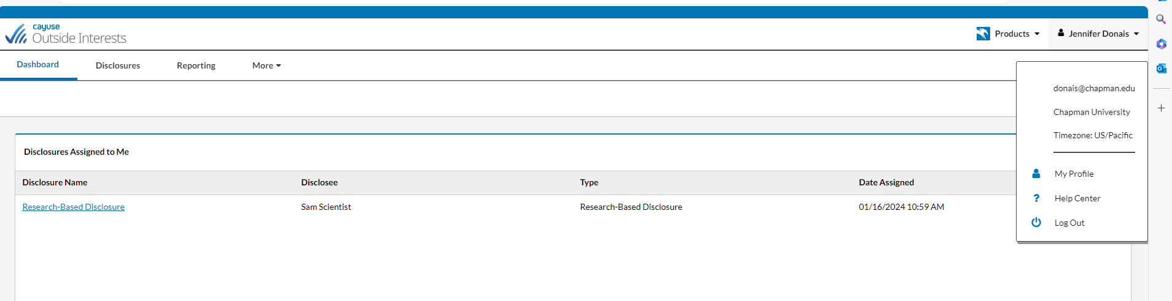
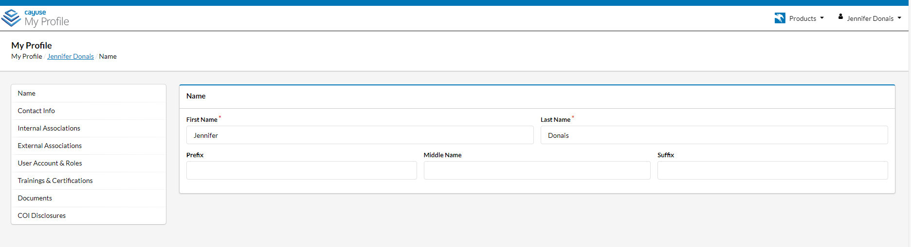
- Select + New Disclosure to start either an Annual or a Research Based disclosure (N.B., do not use the “Modify” button on any existing disclosures you’ve already made).

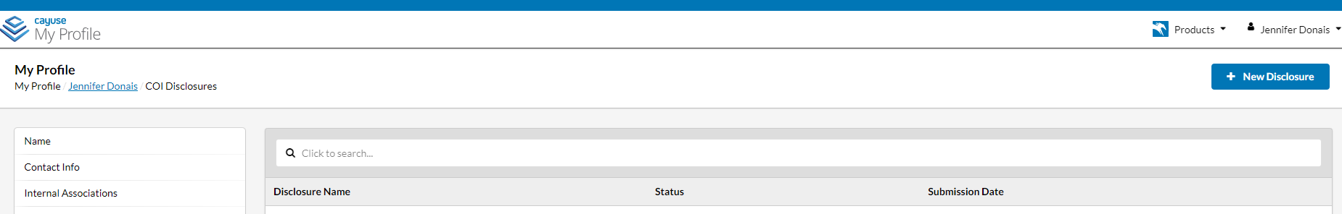

- Select the type of disclosure you are seeking to make (i.e., Annual or Research Based). For Spring 2024, all initial disclosures submitted through the system should be Annual disclosures.
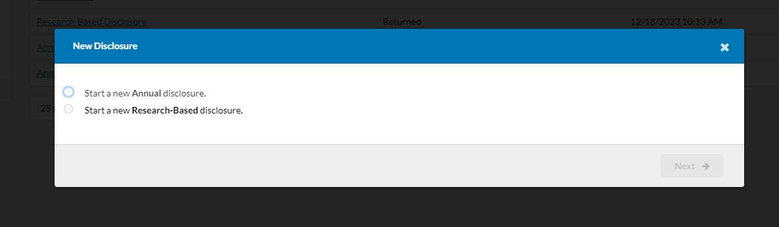

- Provide appropriate responses and relevant information via the smart form disclosure, navigating to each section by clicking “Next” at the top right or selecting the specific section from those listed down the left side of the screen. The disclosures are smart forms with branching logic that will reveal follow up questions or necessary actions (e.g., add an entity) based upon your yes or no answers.

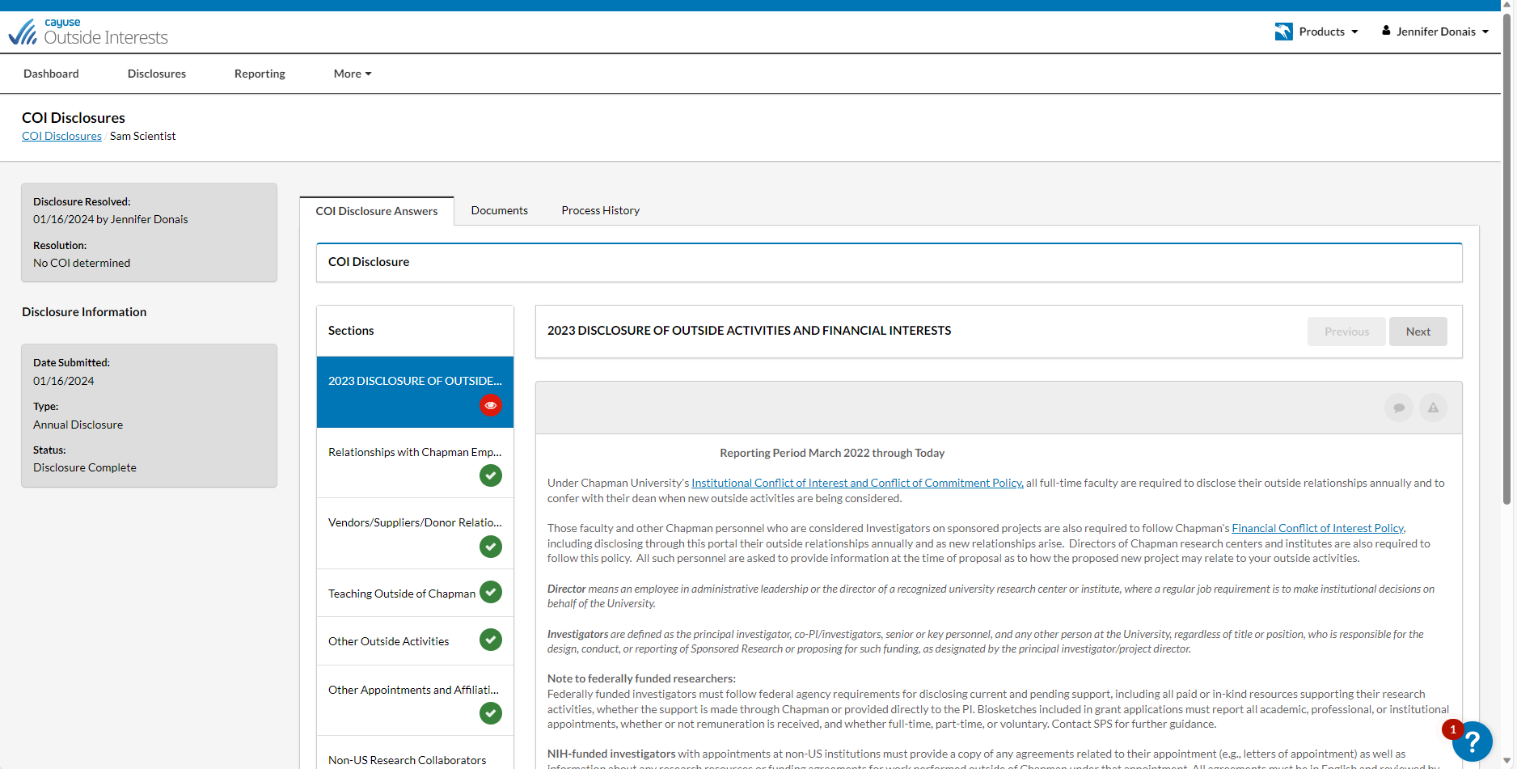

- The system will launch an organization section when disclosers click “Yes.” This section of the form captures information about Significant Financial Interests (SFIs) you have with outside organizations. The “SFI” entity form captures information helpful for conflict of commitment/conflict of interest review and analysis.
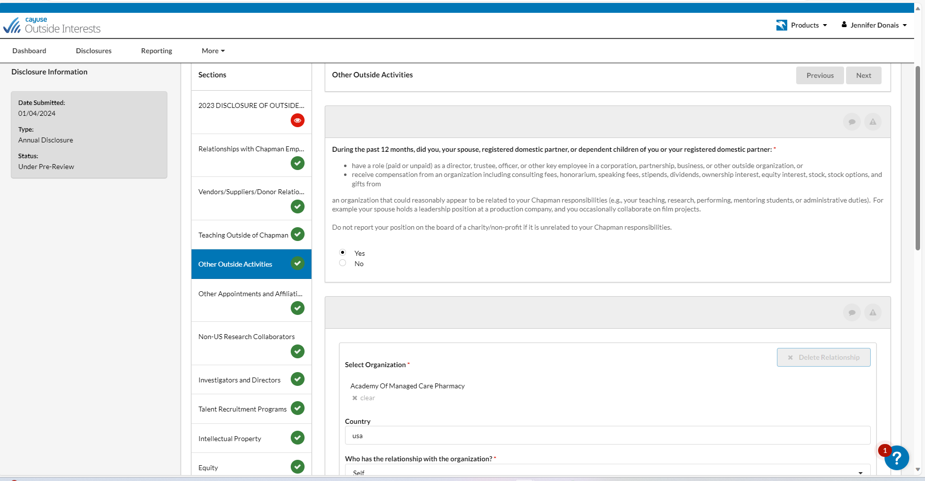

- Search for the organization and click add, then complete the SFI entity form by responding to each prompt. (N.B., incomplete mandatory fields will prevent submission; they are marked with a red asterisk.) Provide as much detail in your responses as possible to aid the dean and other reviewers in understanding your circumstances and activities.
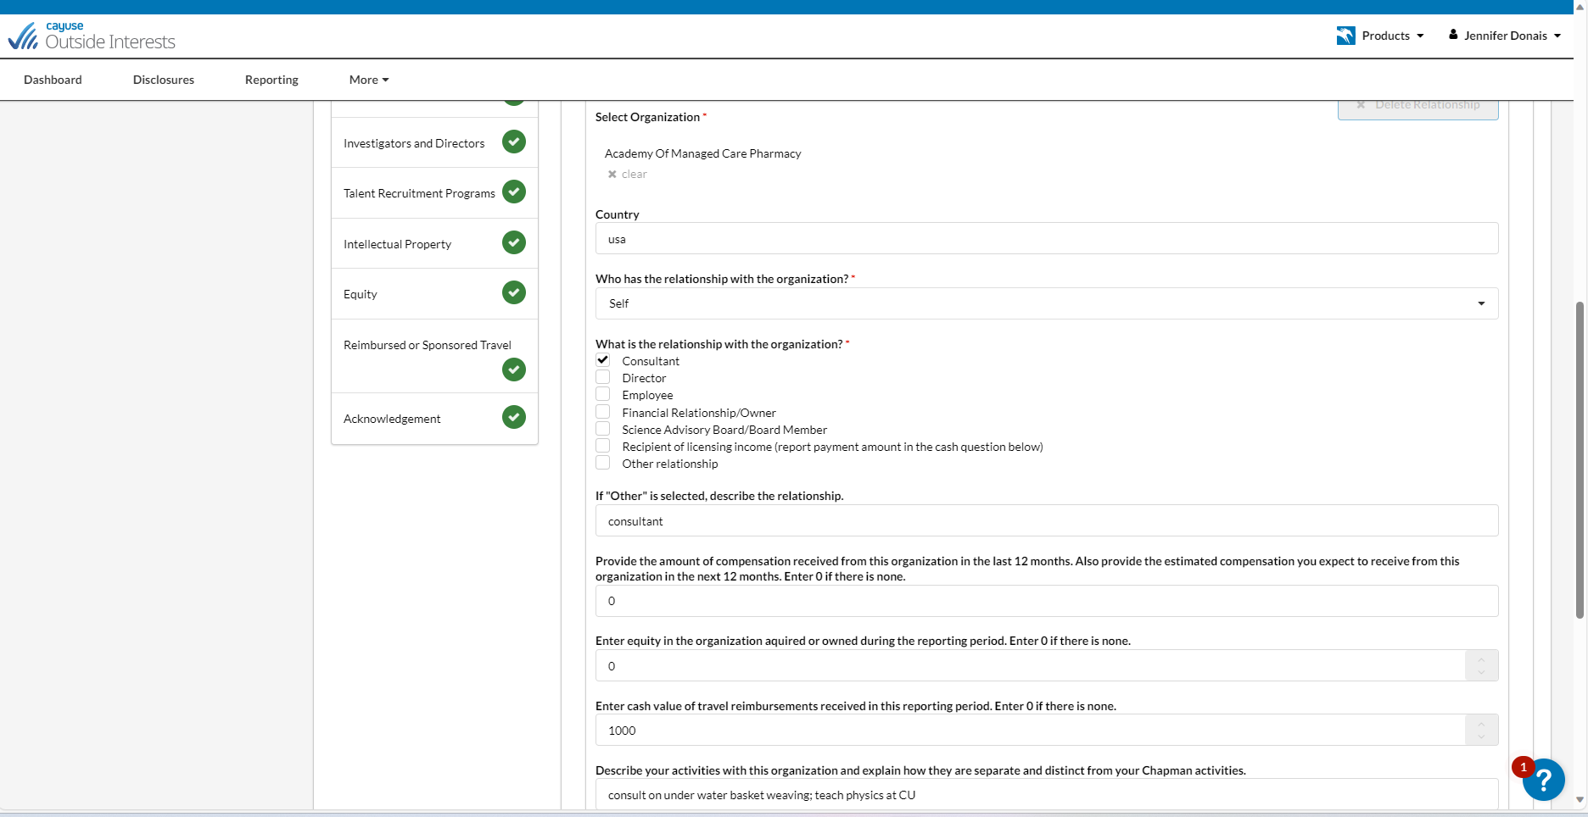

- Complete all sections of the disclosure form, click the acknowledgement statement and then the Submit button.

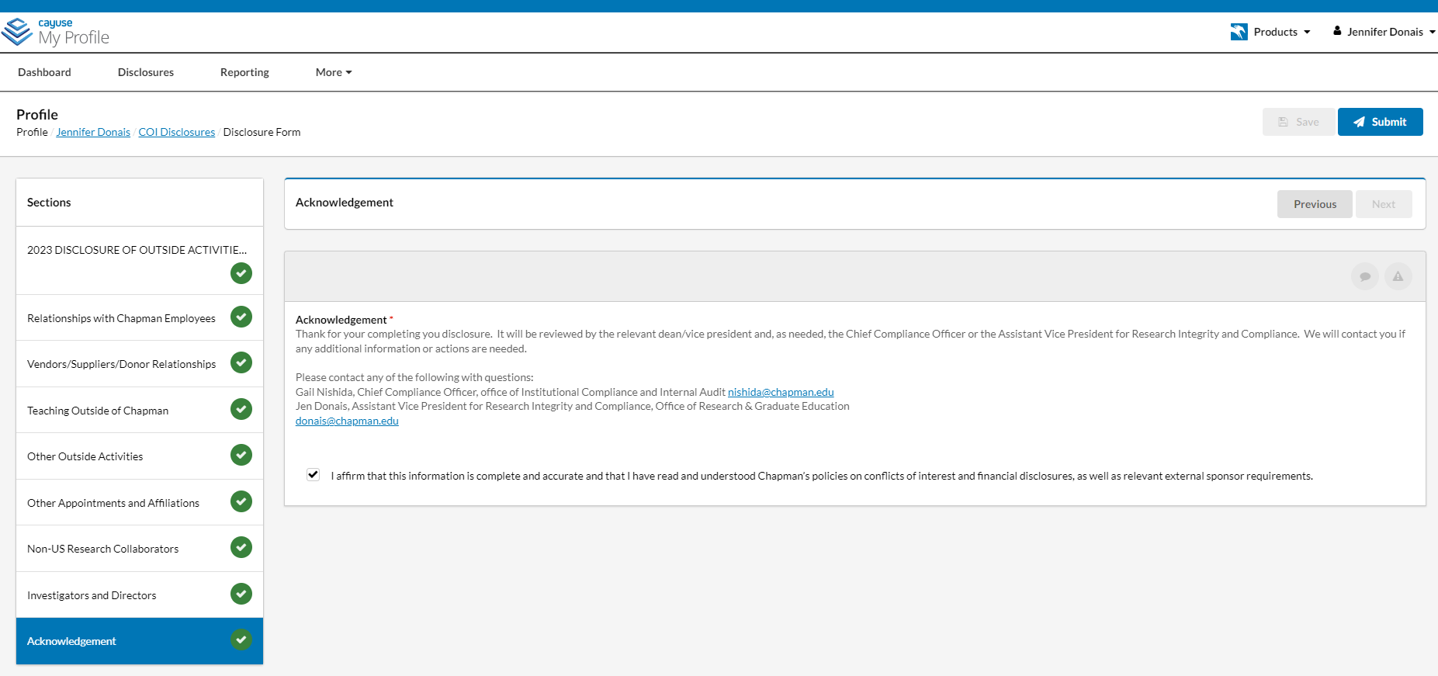

After Disclosure Submission

Once you have completed and submitted your disclosure, your dean and others on the disclosure review team will take over the process; they will be in touch with you as needed for clarifications or additional information.

You can check the status of your disclosures in the system at any time by selecting “My Disclosures” from the “My Profile” page.
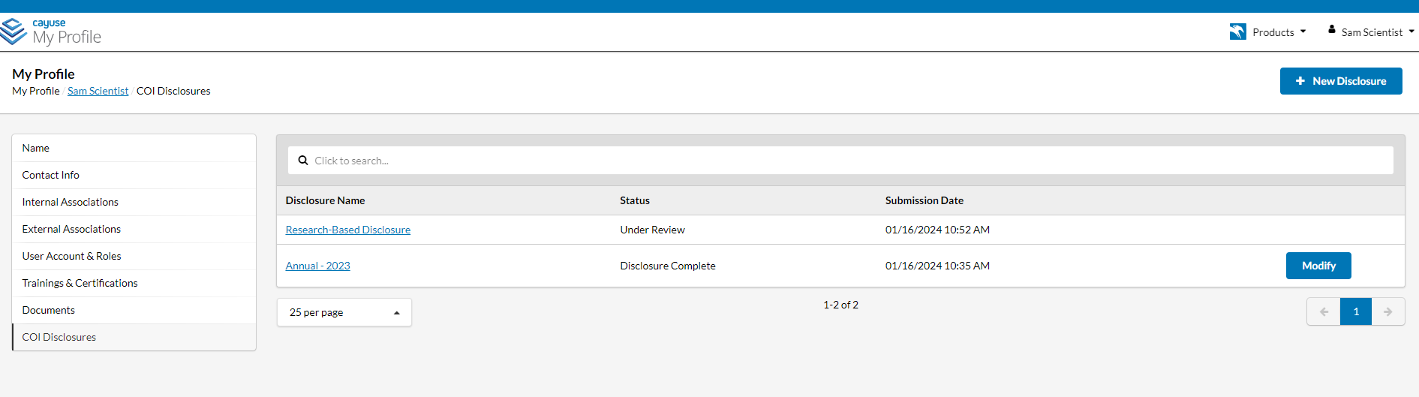

For Faculty Investigators and Directors

Investigators who experience a triggering circumstance after submission of their Annual disclosure (but prior to the next Annual) must use the Research Based disclosure (RBD) to add new activities, engagements or relationships. (N.B., you should not remove existing relationships/organizations using the RBD, although the system offers you that option; any deletions you wish to make to existing relationships/activities should be made upon the submission of your next Annual disclosure; contact Jen Donais if you have questions or concerns regarding the cessation of an activity previously reported.)

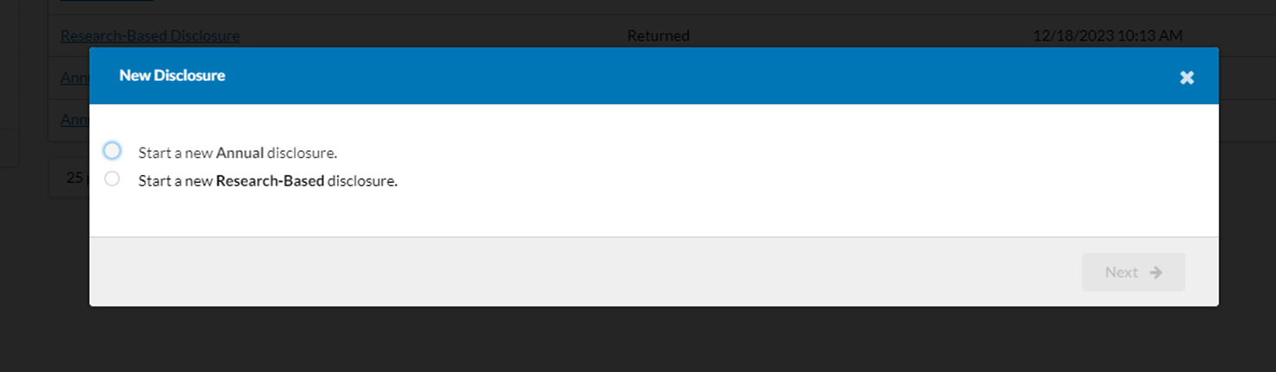

Once you have launched the RBD, you should use the check boxes to indicate those sections where you need to add information (this step opens them up for updating). The system will carry forward any existing organizations/relationships for you to review and affirm. (Please remember, even if that engagement has ceased, do not delete it here – simply review and affirm; deletions should be done at the next annual disclosure submission.)
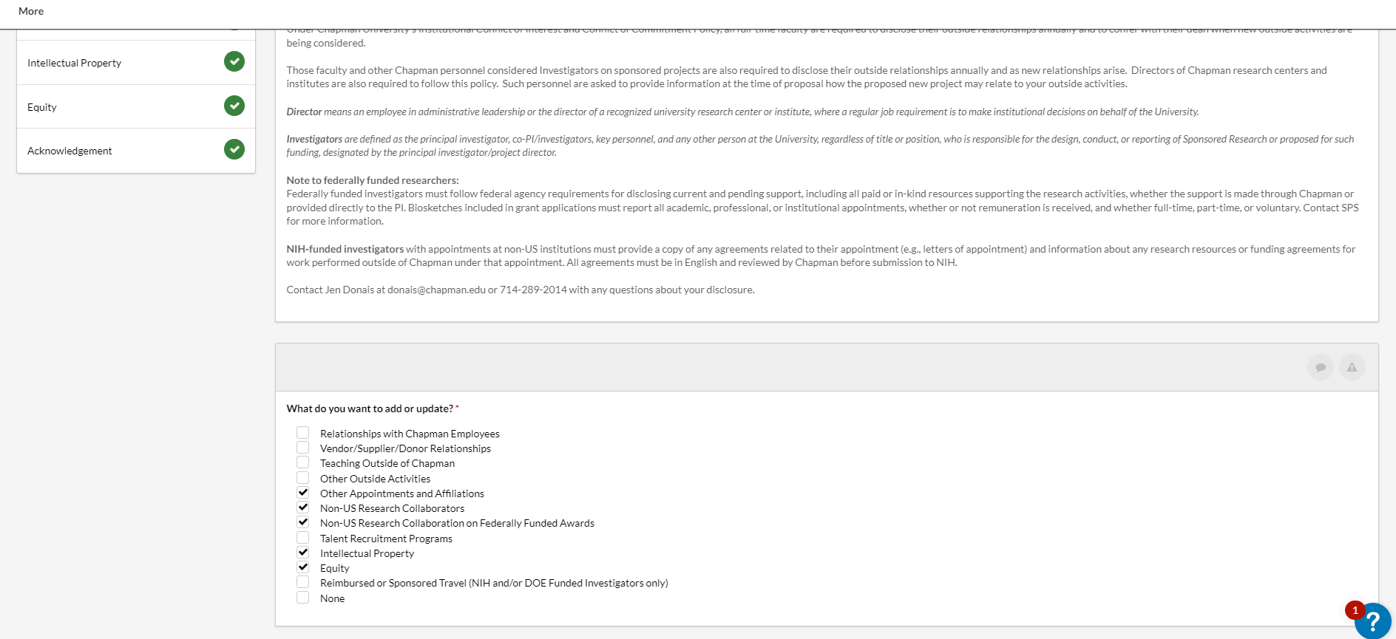

Research Based disclosures, and any engagements they include, will be reviewed and analyzed for relatedness to Federally funded activities; resulting actual or perceived conflicts of interest will be managed and reported, or eliminated, as required by the applicable Federal regulation, policy or guidance.

Questions?
Contact Jen Donais in the Office of Research and Graduate Education at donais@chapman.edu or by phone at (714) 289-2014

Once your Annual is submitted, use the Research Based disclosure (RBD) to update your activities throughout the year when applying for, or receiving, Federal funding. Please note you may only add entities/engagements using the RBD, not remove them. If an activity has ceased, you should remove it on your next new Annual disclosure. Do not use the “Modify” button for any disclosures. If you wish to document the cessation of an activity before your next annual, please email Jen Donais donais@chapman.edu for assistance.
If the organization is not already included in the pick list, follow the instructions to request that the Office of Research add it to the database.
If you answered “No” to each question, the disclosure will be automatically approved, and you will receive a confirming email.
Principal investigators, research faculty and center or institute Directors are all required by Chapman policy to make Research Based disclosures.
For Federally funded faculty, triggers include submission of a Federal proposal, receipt of a Federal award, or the addition of a new activity/engagement. Federal regulations, policies and guidance mandate that these events prompt you to update your disclosure so Chapman can evaluate the new relationship and advise you on any steps needed to comply with Federal requirements.

