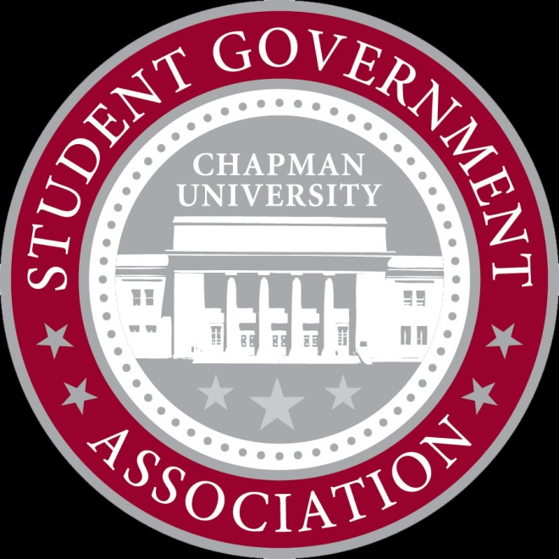
Allocations Committee Meeting

X___________________________
November 13, 2012
6:00 PM

- Attendance
  - Present: Devon, Myke, Zach, Kellyn, Sam, Anthony
  - Tardy:
- New Business
  - KSA Movie Night/Meeting
    - Requesting $50 for movie night
    - Late, have to deny
    - Rejected
      - 4 in favor, 0 opposed
  - ASL Club
    - Requesting $3,109.98 for comedy speaker, expected attendance 40
    - Has to go to full senate
    - Send with recommendation of $1,000
      - 4 in favor, 0 opposed
  - APSA
    - Requesting $675.00 for club sweatshirts
    - Approved $270.00 ($9.00 per sweatshirt)
      - 3 in favor, 1 opposed
  - Conference Scholarship – Nathan Flanagan-Frankl
    - Requesting $700.00 for travel and lodging
    - Leadership conference, it is a great opportunity
    - Approved $700.00
4 in favor, 0 opposed
  - KSA – Liberation in North Korea
    - Requesting $48.00 for dinner for documentary guest speakers
    - Approved $48.00
      - 4 in favor, 0 opposed
  - Calliope Literary Magazine
    - Requesting $7500.00 for extra issue in print
    - Must go to full senate
    - No allocations recommendation, will present both sides
    - Send to Full Senate
4 in favor, 0 opposed
  - Invisible Children SOCF
    - Requesting $4500.00 for Student Org Conference Scholarship
    - 30 students will be going at $281.25 each
    - Allocations recommends to fund in full
    - Send to full senate
4 in favor, 0 opposed

  - Meeting Dismissed 6:38

