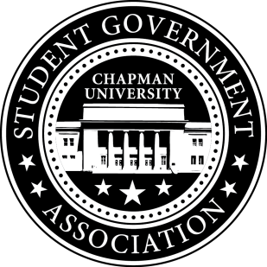
Allocation Report | October 30, 2015
- Funding Requests
  - AAU’s Future of Sustainability Conference
    - Abbygail Quick
    - 11/25-28
    - Requested Amount: $982.00
    - Vote: Fund in full (Unanimous vote)
  - United Nations Framework Convention on Climate Change
    - Clayton Heard
    - 11/30-12/11
    - Requested Amount: $1,000.00
    - Vote: Fund in full (Unanimous vote)
  - National Communication Association 101st Annual Convention
    - Lauren Henderson
    - 11/19-22
    - Requested Amount: $893.87
    - Vote: Fund in full (Unanimous vote)
  - Western Society of Naturalists
    - Nelson Gould
    - 11/5-8
    - Requested Amount: $923.56
    - Vote: Fund in full (Unanimous vote)
  - Western Society of Naturalists
    - Seth Yund
    - 11/5-8
    - Requested Amount: $513.62
    - Vote: Fund $513.32 (Unanimous vote)
  - Weekly Tabling Event
    - Chapman’s Voice for Animals
    - 11/5
    - Requested Amount: $350.56
    - Vote: Fund in full (Unanimous vote)
  - Fall 2015 Induction Ceremony
    - Gamma Beta Phi Honor Society
    - 11/15
    - Requested Amount: $412.30
    - Vote: Fund in full (Unanimous vote)
  - Halloween Party
    - Digital Arts Media Club
    - 10/30
    - Requested Amount: $377.62
    - Vote: Fund in full (Unanimous vote)
  - Philosophy Club T-shirts
    - Chapman Philosophy Club
    - 11/5
    - Requested Amount: $444.00
    - Vote: Defer in order to request an exact headcount of the organization (Unanimous vote)
  - Black/Red Streamers
    - Panther Pack
    - 11/7
    - Requested Amount: $230.79
    - Vote: Fund $115.40 (Unanimous vote)
  - A Taste of France
    - French Club
    - 11/15
    - Requested Amount: $450.00
    - Vote: Fund $0.00 (3 in favor, 2 against)

