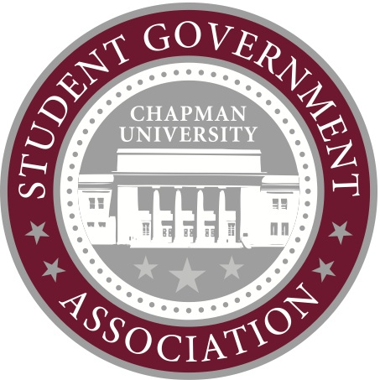
Contact:
Ashley Kaplan
Director of Public Relations
sgapr@chapman.edu

March 3, 2014

In response to The Panther’s recent article, “7 Ways SGA Could Use Its Money,” the Student Government Association would like to address inaccuracies presented. SGA feels that misinformation does not improve the community and results in unaware students. SGA would like to clarify a few points made in the article.
SGA continues to fund water bottle filling stations. SGA has fully funded every request for a new water bottle filling station submitted from Facilities, including one this semester. We foresee this partnership continuing in the future. As for the other projects mentioned in the editorial, bike sharing has been tabled indefinitely due to cost, which was in excess of the SGA reserve fund.
Last year’s president, Chris Joondeph, was working with the administration on students being able to use their declining balance at restaurants and stores in the local area. Admittedly, no one has been actively working on this project, but SGA will reinvigorate its efforts to make this happen.
As the Panther noted, SGA and UPB used to be one entity called Associated Students (AS). One of the main reasons splitting into two entities was so that the legislative branch of AS would focus on advocating and not on programming. It is not part of SGA’s mission to plan programs and unfortunately it is not equipped to help students through the event planning and execution process. Fortunately, the Department of Student Engagement has student staff members who can provide that support and assistance. At the end of the day, the events we give funding for are for another organization that is in charge of their own marketing and advertising.
SGA does receive the largest portion of the student activities fee. In response to the articles in last week’s Panther, SGA President Natalya Subbotina organized a meeting of the heads of Chapman Radio, University Program Board, and the Panther to discuss how the student activities fee is allocated among the groups. Unfortunately, it had to be rescheduled in order to accommodate everyone in the meeting. SGA is open to discussion about reallocating the fee, but also encourages all fee recipients to use what they receive each year in addition to any rollover funds that are currently in their accounts.
While, we already fund free coffee in the library the week before and the week of finals, SGA would love any additional feedback from students on how they think the reserve fund should be used. Last week, Senate voted to pay for additional electrical outlets in the student union so students would be able to charge their devices more easily. Should you have any other suggestions on ways to use the reserve fund, please don’t hesitate to contact one of the senators (their contact information is on our website) or to stop by our Senate meetings, which are at 1 p.m. every Friday in the Argyros Forum boardroom.

