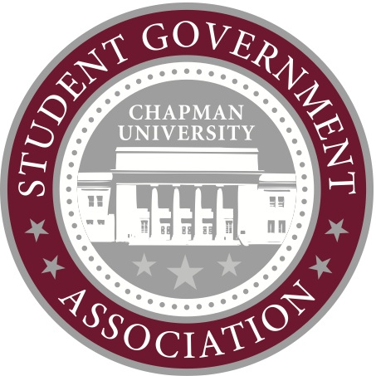
Contact:
Rachel Tilghman
Director of Public Relations
sgapr@chapman.edu

FOR IMMEADIATE RELEASE

Orange, Calif. – Chapman University Student Government Association hosted their annual Fall Retreat on Sept. 22-23 at Alpine Meadows Camp in Angelus Oaks, Calif.
A total of 26 students were in attendance, including senators and members of the executive board. The mandatory retreat outlined project management and goal setting for Senators. Presentations were given by SGA President Chris Joondeph, Vice President Brenton Burke, Speaker of Senate Brandon Tracey.
“We felt that it was extremely important to give Senate a lot of substantive information on Chapman University’s inner- workings to help them be successful in accomplishing their individual projects,” said Joondeph.
Director of Finance Kellyn Hodge covered information on finance and allocations procedures, and Director of Public Relations Rachel Tilghman presented on social media management and media relations.
All members of SGA participated in Strenghtsquest activities, presented by Assistant Director of Student Affairs and SGA Advisor Colleen Wood. Prior to retreat, students took the online Strengthsquest assessment. During retreat, they were asked to share their top five “strengths” in a discussion led by Wood.
“Retreat gave me the opportunity to learn more about the leadership and work styles of my fellow senators so we can work well as a team,” said Dodge College of Film and Media Arts Senator Devon HIllard. “We accomplished so much in just 24 hours, and I feel more connected to the members of SGA. Because of retreat, I see this semester involving collaboration between committees and constituencies as we use our unique abilities and connections to help accomplish the goals of SGA and Chapman students.”
Students enjoyed team building and bonding activities, and spent Saturday evening roasting marsh mellows and making s’mores around a camp bonfire.
“The retreat helped me establish personal connections with people I didn't know two days ago that I am now confident in,” said newly elected Freshman Class Senator, Vaugan Ryan. “I feel like now I have support of knowledgeable and enthusiastic peers as I learn more about Senate and work with my fellow senators to accomplish common goals.”
The retreat cost, including transportation, food, lodging and activities totaled just under $2,600. Fall retreat is allocated from the SGA Internal Development budget. The Internal Development Budget was approved by Senate in Spring 2012, and totals $14,000.
“After retreat, I feel inspired to work harder for my constituency,” said College of Educational Studies Senator Natalya Subbotina. “I am confident in my projects and feel unconditionally supported by the rest of Senate in my efforts.”
The students not in attendance were Erin Wainwright, Schmid College of Sciences senator, Connor Bogenreif, College of Perfoming Arts senator, and Ashley Widjaja, junior class senator.
There will be additional training at Senate meetings on Robert’s Rules of Order and other procedures, and SGA will host its on-campus spring retreat in February 2013.
“The retreat was extremely important because it brought us closer together as a group, established our priorities for the year, and helped to give senators the tools they will need to succeed in office,” said Joondeph, “It was a success. I am very pleased at how much the senators were able to take away from the retreat.”
Please contact the Director of Public Relations, Rachel Tilghman, with questions.
###

